Introduction:

Advances in technology have had a significant impact on event planning

and event registrations in particular. Long gone are the days of paper invitations that arrive in an envelope with a stamp. Online registration is increasingly common for every type of event, from business seminars and annual conferences to mile stone birthday parties and company holiday functions. While this online process may seem simple, it still requires work.

Many of the internet users are using different kinds of websites and applications. Here we are creating an interface for event registrations.

Some of the websites which will support for event registrations are cevent , Eventbrite , event smart , eventzilla etc.

Abstract:

It is designed for the easy event registrations of students in their particular university. We can make it both paid and for free. This is the kind of thing what we have made it to helpful for the Both students and organizations.

Libraries used:

Tkinter: Tkinter is used for to design the inter face

Random: Random is used for pseudo number generating function.

Math: The math module is used for doing math functions.

Time: It is used to show date and time in the application.

How program works?

First, we will get an interface about to login into the page.

Because by logging into the webpage we can register the event.

Here we have to through the LPU registration number

and UMS password.

Here we are having two categories.

1)Paid event registrations

2)Free event registrations

This is especially made for the students of LPU.

This method would be very helpful for the students of lovely professional university.

In past students used to write down the website in their notes.

We noticed that some of the students dose not even bring the

Class notes to the class. This makes the student to register in

Any event which he or she wants to do.

How program works?

On the daily basis students have to check their ums if they had

any notification about the event they had registered.

It would be difficult for the students to see their notifications

About the event registered. But by registering through this

website it will give the notifications.

We can

the notification by selecting on the category what

He or she wants.

There are several kinds subjects and categories we are

delivering a sample how it works.

By using this project, it would be helpful to ,

Students and the organizations which conducts the events

To ensure the student to attend the event and make it

Successfully.

How program works?

Here previously we have said that there would be two

Categories paid and free. Every category will have

departments same. If any special event was been conducted

it will appear as pop-up box.

There are different types of departments such as:

Computer based

Programming based

Electrical based

Automobile based

Spoken English based

Hotel management based

Business based

Architecture based

Film making based

Sports based

Society based etc...

These are the departments which we can conduct an event and

register through it.

How program works?

We know that for paid events we have to pay for it.

Here before registering to the event we have to pay.

For the payment there are many ways as of university

way we are by card payment. At First, we have to enter the

card number and CVV code. Then you will get an OTP to

your registered mobile number. By entering the OTP you

will get a pop-up box that your payment successful.

And then there will be an another page opened that

Your event has been registered successfully.

Here it is the way we known that, how an event registration

Website works.

Conclusion: By using this kind of website we register any

Kind event we want to do. Every university should consist of

these kinds of websites. This has been done through the help

of python programming. By using it we can design and do a

wonderful, efficient websites.

Data flow diagram:

Data flow diagram for event registration:

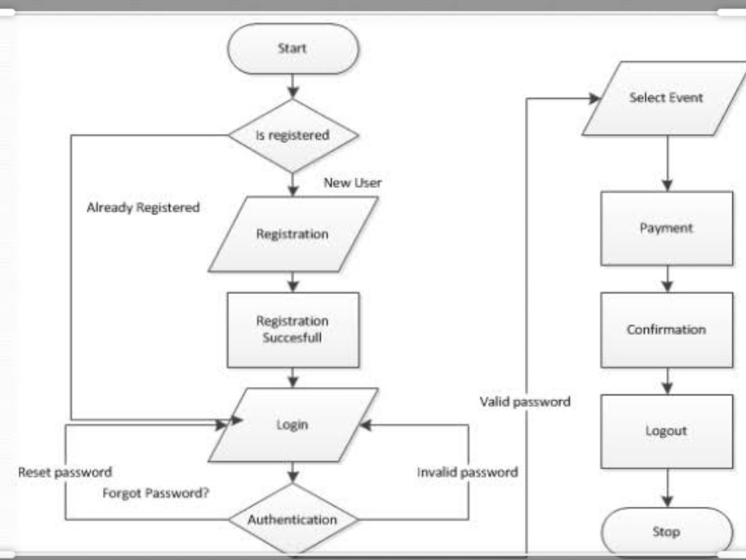

Modules

* We will have at most five modules
* One is for login page.
* One is for details
* One is for data management
* One is for payment
* One is for confirmation.

Team Roles

B.Vineeth Reddy - Report, data management

K.D.S.Harsha - GUI,Data base.

References:-

* https://www.tutorialspoint.com
* <https://www.geeksforgeeks.org>
* <https://www.w3schools.com/python/python/mysql/create/db.asp>
* <https://www.eventzilla.net/us/home>